**Emergence of Technologies Questionnaire II**

Name: Dishant Tekwani_______________________________________________________

Student Number: 20309212________________________________________________

Programme: comp science_______________________________________________________

(a) Ada Lovelace is famous because: She was the first computer programmer__________________________________________________________________________________

__________________________________________________________________________________

__________________________________________________________________________________

(b)



What is this mechanical device and what does it measure?

It measures length__________________________________________________________________________________

(c) List in the order of their development

Log tables _______1614

Napier’s bones _____1617

Slide Rule _______1814

Electronic calculators _______1967

Curta pocket calculator _______1972

(d) State any of Isaac Asimov’s Laws of Robotics.

A robot may not injure a human being or through inaction allow a human being to come to harm __________________________________________________________________________________

(e) List some potential risks and rewards of genetic engineering.

Risks – 1. Harm to health

2. Harm to environment

3. Risk assessment _______________________________________________________________________

___________________________________________________________________________

___________________________________________________________________________

___________________________________________________________________________

___________________________________________________________________________

___________________________________________________________________________

Rewards – 1. More nutritious food

2. Tastier food

3. Faster growing plants and animals

____________________________________________________________________

___________________________________________________________________________

___________________________________________________________________________

___________________________________________________________________________

___________________________________________________________________________

___________________________________________________________________________

___________________________________________________________________________

(f)

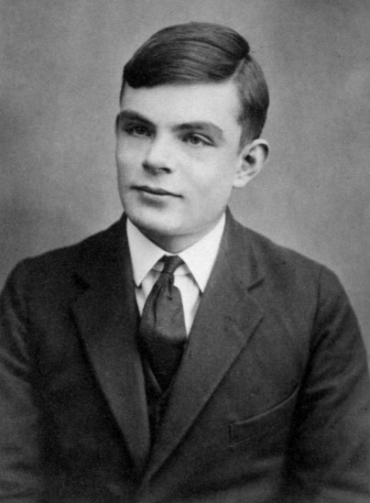

What is the significance of this man’s test? _______________________________________________

__________________________________________________________________________________

__________________________________________________________________________________

(g) Give an example of a material that made a new technology possible:

Material silicon_________________________ technology semiconductors_________________________________

(h) List ten occupations that are likely to me made obsolete by new technologies in the next twenty years:

1. Travel agent. ...
2. Cashier. ...
3. Fast food cook. ...
4. 4. Mail carrier. ...
5. Bank teller. ...
6. Textile worker. ...
7. Printing press operator. ...
8. Sports referee/Umpire.
9. Retail jeweller
10. dispatcher

(i) Which comes first, the science or the technology? ______________________________________

**Technology first appeared during the lengthy evolution process from apes to humans**

(j) In twenty years, the most sustainable technologies of producing energy are likely to be _________

**Hydroelectric power, using the potential energy of rivers**

(k) What is the relevance of Maslow’s Hierarch of Needs to the emergence of technologies?

According to Abraham Maslow's Hierarchy of Needs, **people have a deep-seated need for self-creation, mastery, discovery, and connection**. Apply this theory to the technology experiences you produce for your users, and suddenly the Hierarchy of Needs starts to make a lot of digital sense as well.

(l) What is the principle of public key encryption?

Public-key cryptography, or asymmetric cryptography, is an encryption scheme that **uses two mathematically related, but not identical, keys - a public key and a private key**. Unlike symmetric key algorithms that rely on one key to both encrypt and decrypt, each key performs a unique function

(m) What is blockchain and how is it related to crypto currencies? A blockchain is **a decentralized ledger of all transactions across a peer-to-peer network**. Using this technology, participants can confirm transactions without a need for a central clearing authority.

(n) Mark Brunel, Henry Maudslay and Samuel Bentham where involved in the design and manufacture of the machine shown below, which is often taken as the start of mass production.



What did this machine produce?

__________________________________________________________________________________

(o) The app I would most like to see developed is health check up and food planner app

(p) List the ten most significant technologies that are vital to world trade

1. Blockchain · 2. Artificial Intelligence and Machine Learning · 3. **Trading** services via digital platforms · 4. 3D-printing · 5. Mobile payments. 1. Blockchain · 2. Artificial Intelligence and Machine Learning · 3. **Trading** services via digital platforms · 4. 3D-printing · 5. Mobile payments.

(q) Kodak was the first company to develop digital cameras. Why did Kodak delay bringing their new technology to market? __________________________________________________________________________________

__________________________________________________________________________________

__________________________________________________________________________________

(r) Companies with access to my personal data will be able to identify:

That I am no longer a student because i dont use my school email

That I have bought a house because i pay bills online

___________________________________________________________________________

That I might be a potential customer for life insurance because i went through an accident or got a disease

___________________________________________________________________________

That selling me life insurance would be a high risk because i live in a disease rone area

(s) The Xerox Alto, shown below,



was the inspiration for what? __________________________________________________________

__________________________________________________________________________________

(t) Why was Isambard Kingdom Brunel’s Great Eastern a failure?

__________________________________________________________________________________

__________________________________________________________________________________

(u) Name one film or novel that you have read or seen that you believe presented a credible

dystopian future _____________________________________________________________

What technological development do you believe is most likely to result in humanity’s self-

destruction? ________________________________________________________________

(v)

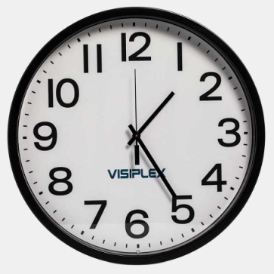

At what time will the hour hand and minute hand next cross?

______Hours ______minutes ______seconds

(w) Mathew Boulton said “I sell here, Sir, what all the world desires to have – _________”. Fill in the

blank and explain what it was that Boulton sold. __________________________________________

(x) What potential technical development that might occur in the next fifty years would

have the greatest impact on humanity? _________________________________________________

__________________________________________________________________________________

(y) That the emergence of technologies follows an evolutionary model can be seen from the development of ____________________________________________________________________

__________________________________________________________________________________

The limitations of using evolution as a model for how technologies emerge can is demonstrated by __________________________________________________________________________________

__________________________________________________________________________________

(z) What WWII communication system is contained within the boxes in the picture below?



__________________________________________________________________________________

__________________________________________________________________________________

__________________________________________________________________________________